Title of Short Paper for ILASS Europe 2023 Title of paper for ILASS 2014Conference
First Author*¹, Another Author², Last Author²
¹Mechanical Engineering Department, University Federico II, Napoli, Italy
²Another Department, Another Institute, Town, Country
*Corresponding author: a.author@university.eu

Abstract
This template illustrates the formatting of short papers for ILASS Europe 2023 proceedings. Please do not change any formatting, such as margins. The abstract should be no longer than 200 words.

Introduction
The typical length of a short paper for ILASS Europe 2023 should be 2-4 pages. Your manuscript must be submitted in PDF file format by e-mail to ilasseurope@stems.cnr.it before May 15th, 2023. The maximum file size must not exceed 10 MB.

Material and methods
The title of the paper is centred text, Arial, font size 14, bold. Authors and institutes are centred text, Arial, font size 11, followed by 1 blank line. Headlines are formatted Arial, font size 9, bold while the text itself is not in bold. The line spacing is 1.15 without spacing before or after a paragraph. If you wish to highlight any text, only use italics.

Results and discussion
You may rename the headlines of each paragraph and/or add new ones. You may insert figures (see Figure 1) or tables (see Table 1) in the text or at the end of the extended abstract. The Proceedings including the full length papers will be distributed electronically (USB-stick). Thus, the use of colours in illustrations and figures is possible.
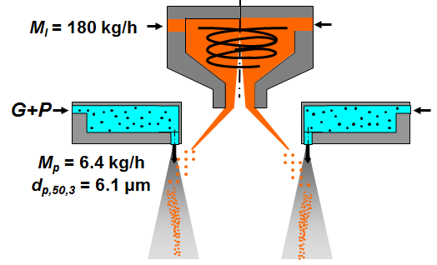
Figure 1. Example of a figure. Caption in Arial, font size 8, centred, Figure and figure number bold. Spacing before caption is 6 pt.
The example in Figure 1 shows how to include a figure into the text. You should use 1 blank line before and after the figure. The same applies to tables. Use the table example format presented below.
Table 1. Example of a table. Caption in Arial, font size 8, centred, Table and table number bold. Spacing after caption is 6 pt.
 | Column 1 | Column 2 | Column 3
Row 1 | 5 | 34 | 67
Row 2 | 6 | 45 | 75
Row 3 | 7 | 46 | 64
Row 4 | 8 | 56 | 53

Please use SI units in all text, figures and tables. Equations should be left-aligned, with the equation number in parentheses in sequential order included right-justified, as in the below equation,
F = ma. | (1)
Equations should be referred to by equation numbers. All symbols should be printed in italics or otherwise according to conventional practice, both in the equations and in the text. There is a spacing of 6 pt. before and after each formula. The nomenclature section should immediately precede the references.

Conclusions

Acknowledgements

Nomenclature
a acceleration [m s⁻²]
F force [N]
m mass [kg]

References
References should be indicated in the text by full sized numbers enclosed within square brackets. Use different formats for journals [1], books [2], symposium proceedings [3] and web pages [4] as illustrated in the examples below. You may use “ASME” citation style in Endnote.

[1] Lee, C. H., and Reitz, R. D., 1999, Atomization and Sprays, 9, pp. 497-517.
[2] Wilcox, D. C., 1993, "Turbulence Modeling for CFD". DCW Industries, Inc.
[3] Lampa, A., and Fritsching, U., Sep. 5.-7. 2011, 24th European Conference on Liquid Atomization and Spray Systems.
[4] Institute for liquid atomization and spray systems, http://www.ilasseurope.org/index.html ([cit. 2014-01-31]).

